**Mendocino College**

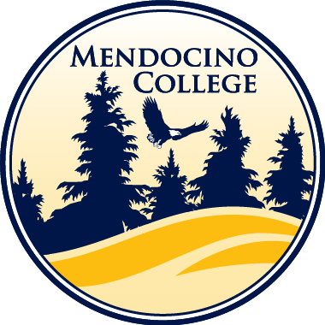**DAM 110 –** Image Manipulation with Photoshop

**Course Schedule –** Fall 2022

**Weekly Topics**

1) Introduction to Adobe Photoshop and Bridge

2) Layers / Transparency / File Formats / Transform, Zoom, & Move Tools.

3) Text Tool / Layer Styles / Workspaces / Fill & Adjustment Layers

4) Filters / Blending Modes / Importing Images / Crop, Frame, & Slice Tools / Contact Sheets

5) Lasso, Selection, Marquee, Brush, & Eraser Tools / File & Project Management

6) Masks / Feathering / Resolution / Gradient & Paint Bucket Tool

7) Shapes / Pen Tool / Resolution / Visual Design Principles

8) Portfolio Site / Logo / Watermarks / Digital Ownership

9) Color Modes / Gamuts / Composition / Black & White

10) Color Correction / Replacing Colors / Design / Camera Raw

11) Retouching / Photo Correction Filters / Sharpen & Blur / Patch Tool

12) Restoration / History Brush Tool / Clone Stamp Tool / Healing Brush Tool

13) Manipulation / Liquefy Filter / Puppet Warp / Smudge Tool / Importing Video

14) Careers & Professions / Resume & Cover Letter

15) Thanksgiving Holiday / Holiday Card

16) How Digital Cameras work

17) Final Examinations and Project Presentations